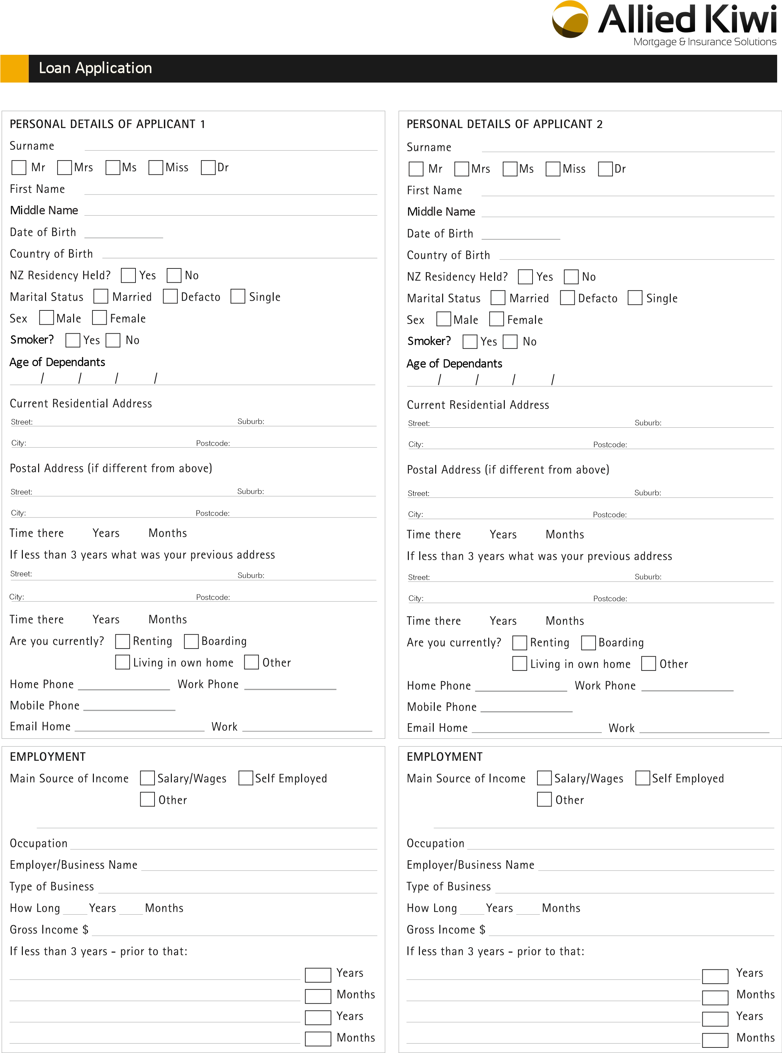[1][2]

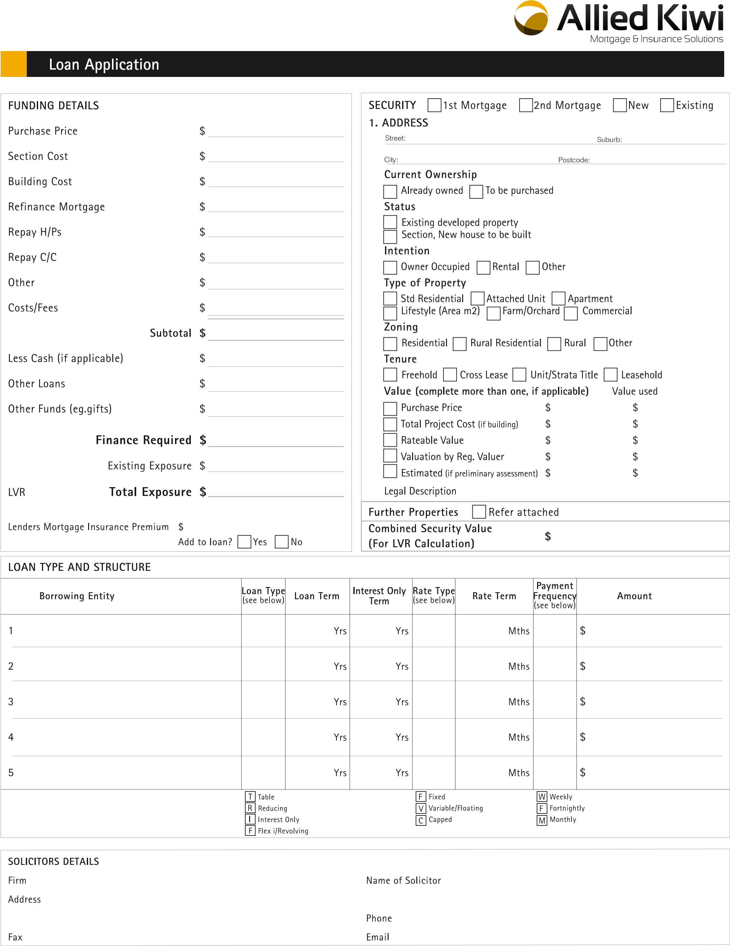



Loan Application



**Loan Application**

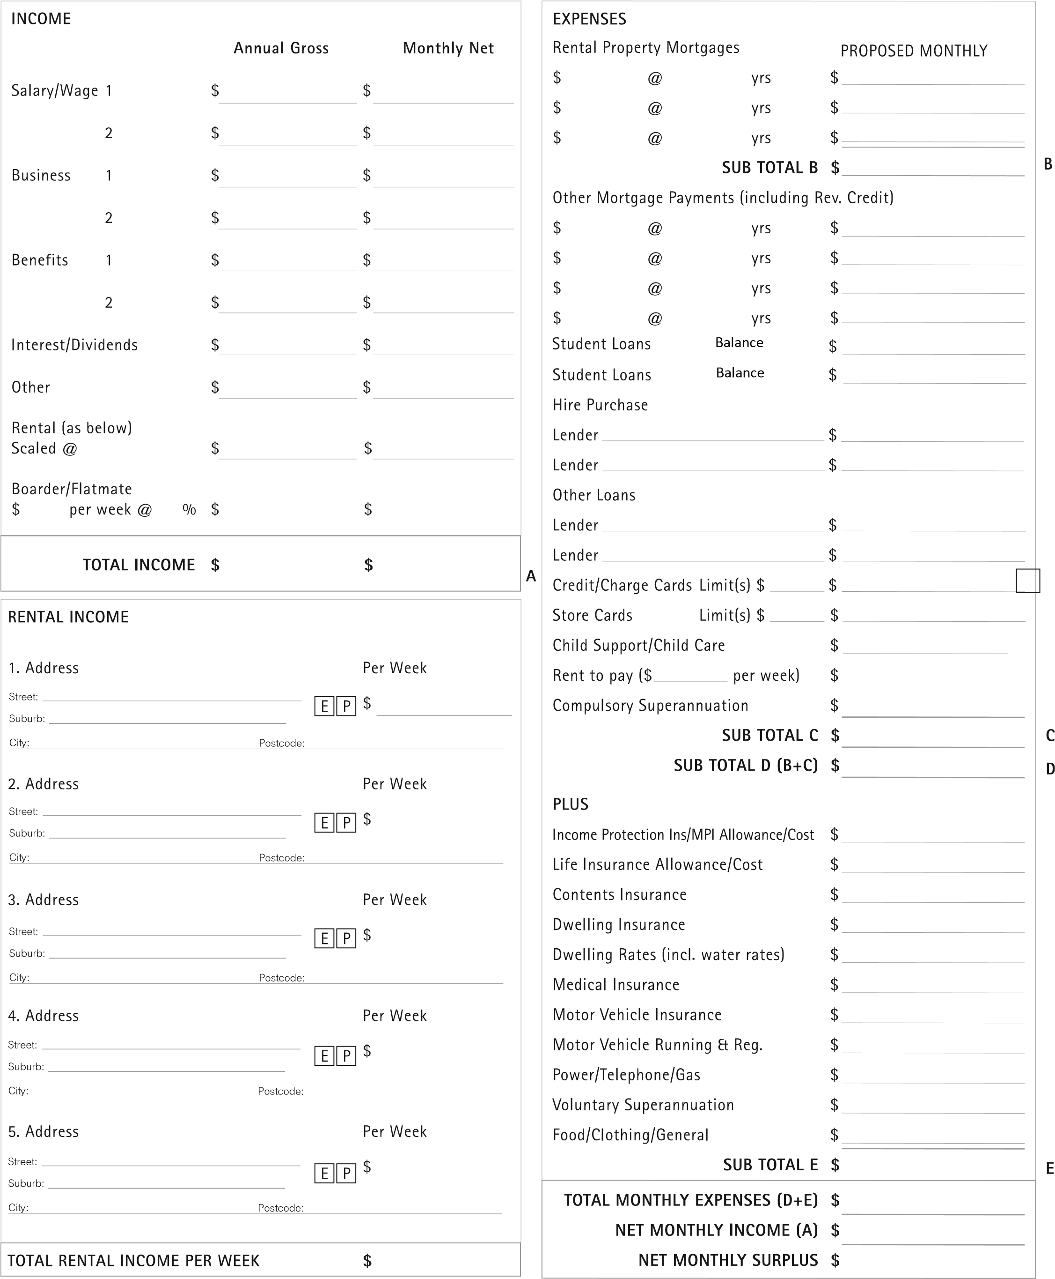

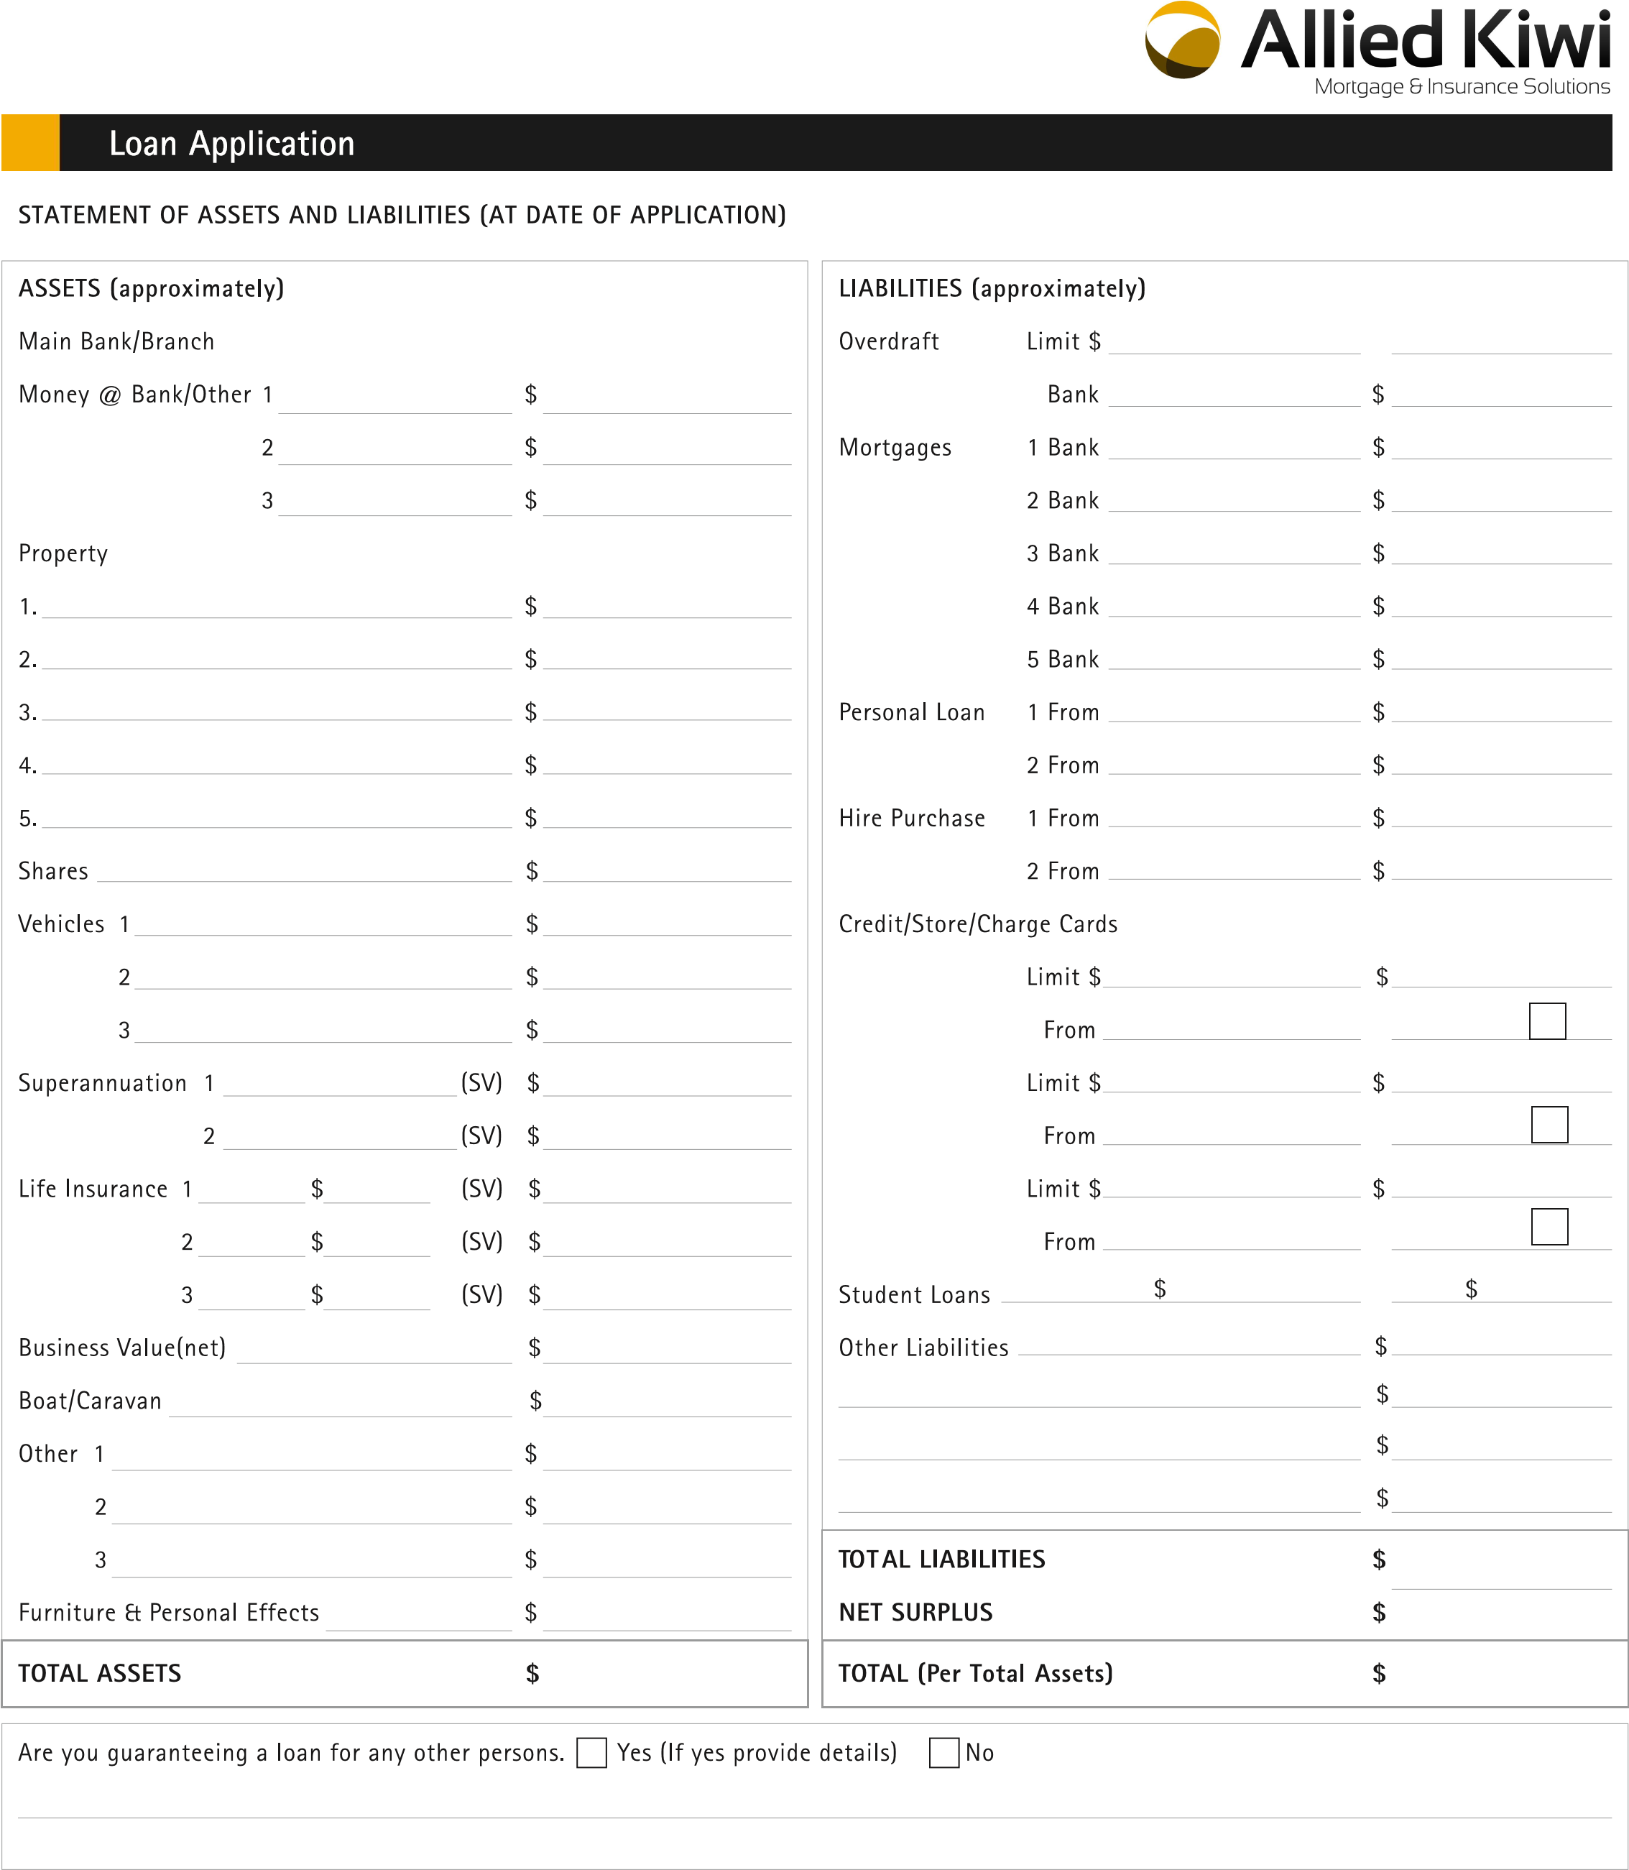

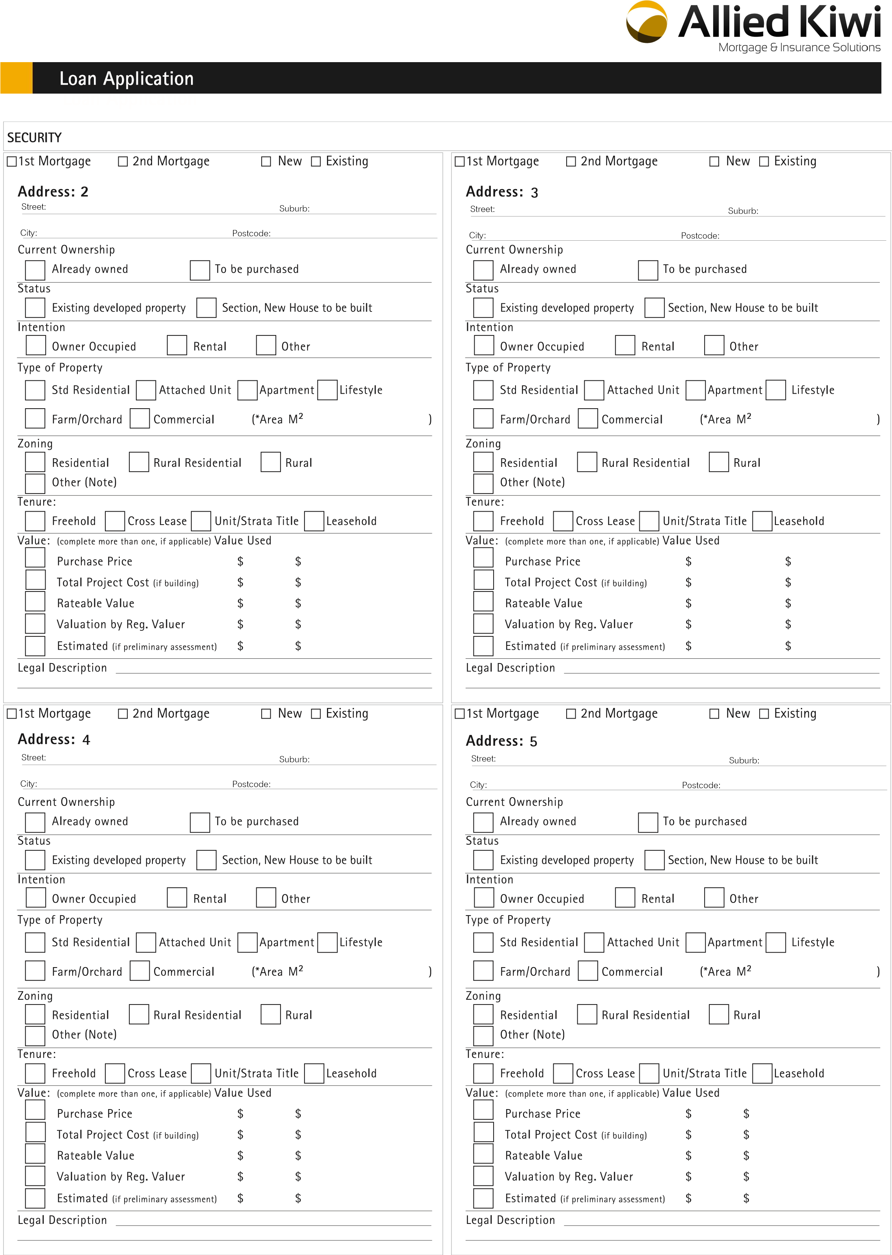

1.
2.